Project Designer support on the Project Framework

Project Designer frame is now supported on the project framework.

The ProjectNode responds to the following properties to communicate that it wants to support project designer.

- VSHPROPID_SupportsProjectDesigner
calls a virtual property called SupportsProjectDesigner
- VSHPROPID_ProjectDesignerEditor:
calls a virtual propery called ProjectDesignerEditor. By default the ProjectNode returns the GUID for the ProjectDesignerEditor

The project node also supports the following virtual methods to provide information about the property pages it supports:

- GetConfigurationIndependentPropertyPages for specifying the configuration independent property pages by reacting to the VSHPROPID_PropertyPagesCLSIDList
If an implementer does not want to support configuration independent property pages it should return an array of Guids zero length.
This method is also called by the NodeProperties implementation of IVsSpecifyProjectDesignerPages and ISpecifyPropertyPages to provide non configuration dependent property pages.
- GetConfigurationDependentPropertyPages for specifying the configuration dependent property pages by reacting to the VSHPROPID_CfgPropertyPagesCLSIDList property.
If an implementer does not want to support configuration independent property pages it should return an array of Guids zero length.
This method is also called by the ProjectConfig implementation of IVsSpecifyProjectDesignerPages and ISpecifyPropertyPages to provide configuration dependent property pages.
- GetPriorityProjectDesignerPages for specifying the order in which application designer property pages are shown as a reaction to the VSHPROPID_PriorityPropertyPagesCLSIDList property.
- GetProjectDesignerPages for specifying the property pages for the application designer. This method is called by the ProjectConfig object GetProjectDesignerPages method that implements the IVsSpecifyProjectDesignerPages interface.
- GetPropertyPageGuids for specifying the property pages for the classical pages. This method is called if there is no support for project designer.

The ProjectConfig object implements the IVsSpecifyProjectDesignerPages and the IVsCfgBrowseObject in order to communicate the configuration dependent property pages with the VS Shell.

The NodeProperties will also implement the implements the IVsSpecifyProjectDesignerPages and the IVsBrowseObject in order to communicate the configuration independent property pages with the VS Shell.

The ProjectNode overrides the GetDocumentManager method and that will instantiate a ProjectDesignerDocumentManager to handle opening and closing of the project designer editor.
The ProjectNode also implements IVsProjectSpecialFiles but leaves the implementation of the GetFile method not implemented. The implementation of this interface is required by the Microsoft.VisualStudio.Editors framework, the framework that creates the project designer frame.

The below class diagram depicts the changes that had to be done on the Project Framework in order to support the project designer.

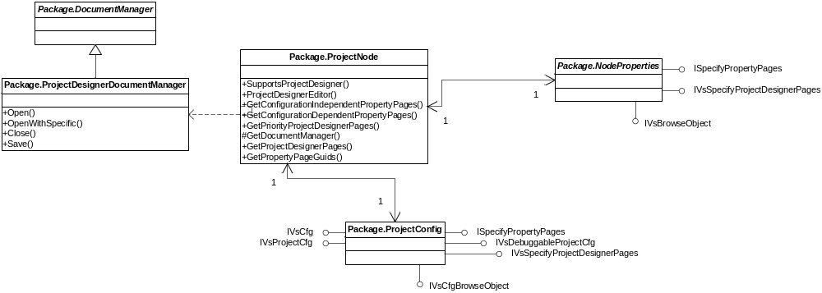

Below there is an activity diagram that shows how the project designer frame is instantiated. The next calls in the diagram would be the instantiation of the specific property pages.

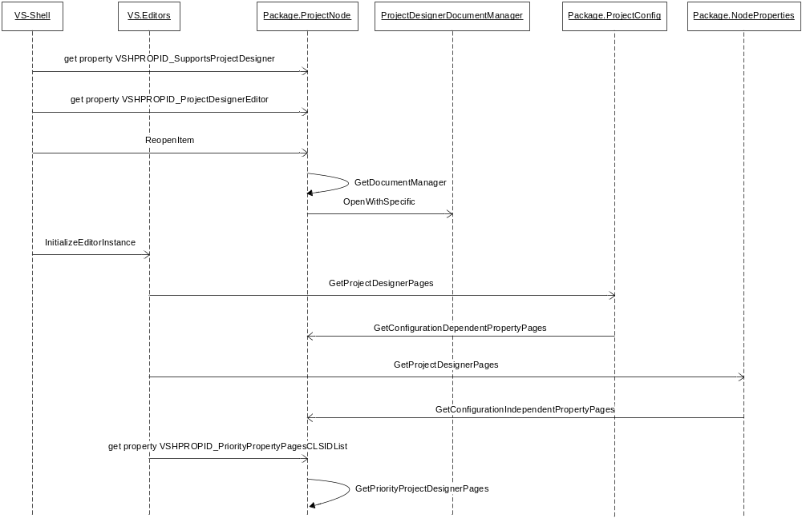

If a project would like to have application designer frame to be shown instead of the old frame it needs to override the SupportsProjectDesigner property on its project Node and set it to true.

Issues with implementing a property page

The Microsoft.VisualStudio.Editors.dll contains the framework and the particular implementation for the VS property pages.
If an implementer does want to use the existing persistence, configuration change and undo/redo scenarios then it should inherit from a public base class provided by this framework called VBPropPageBase
This class has to provide a Guid and will be created by the Vs Core as any other property page.
The class has to override a method where it will create the Property page that is to be shown.
Example:
[ComVisible(false), Guid("1FB2158C-A10D-40b8-90DF-28CE942E06CE")]
public sealed class CSharpApplicationPropPageComClass : VBPropPageBase
{
protected override string Title
{
get { return SR.GetString(SR.ApplicationCaption); }
}

protected override Type ControlType
{
get
{
return typeof(ApplicationPropertyPage);
}
}

protected override Control CreateControl()
{
return new ApplicationPropertyPage();
}

}

The property page class has to inherit from a class called PropPageUserControlBase and has to override ControlData property and list all the controls that this page will create.

Example of a page that has one control.
public partial class ApplicationPropertyPage : PropPageUserControlBase
{
public ApplicationPropertyPage()
{
InitializeComponent();
}

protected override PropertyControlData[] ControlData
{
get
{
if (m_ControlData == null)
{
m_ControlData = new PropertyControlData[] { new
PropertyControlData((int)PropertyPageControlDispId.AssemblyName,
"AssemblyName", this.assemblyNameTextBox, new Control[]
this.assemblyNameLabel}) };
}

return this.m_ControlData;
}
}

}

A resource file named as the page must also be provided with special semantics.
Example:
Resource name : ApplicationPropertyPage.resx
Subtract from the file:
<assembly alias="System.Drawing" name="System.Drawing, Version=2.0.0.0, Culture=neutral, PublicKeyToken=b03f5f7f11d50a3a" />
<data name="AssemblyNameLabel.Location" type="System.Drawing.Point, System.Drawing">
<value>0, 3</value>
</data>
<data name="AssemblyNameLabel.Size" type="System.Drawing.Size, System.Drawing">
<value>79, 13</value>
</data>
<data name="AssemblyNameLabel.TabIndex" type="System.Int32, mscorlib">
<value>0</value>
</data>
<data name="AssemblyNameLabel.Text">
<value xml:space="preserve">Assembly &amp;name:</value>
</data>
<data name="&gt;&gt;AssemblyNameLabel.Name">
<value xml:space="preserve">AssemblyNameLabel</value>
</data>
<data name="&gt;&gt;AssemblyNameLabel.Type">
<value xml:space="preserve">System.Windows.Forms.Label, System.Windows.Forms, Version=2.0.0.0, Culture=neutral, PublicKeyToken=b77a5c561934e089</value>
</data>
<data name="&gt;&gt;AssemblyNameLabel.Parent">
<value xml:space="preserve">TopHalfLayoutPanel</value>
</data>

The problem with this whole design is that in order that all these things to work the implementation of the Object property on EnvDTE.Project has to implement an object of type VSLangProj.ProjectProperties.
Now the VSLangProj.ProjectProperties defines only the properties that a language project understands. Thus only the properties defined by the VSLangProj.ProjectProperties interface will be dealt with by the property page framework.
Also the object that implements IVsCfgProvider must implement IVsExtensibleObject too. That is OK and can be agreed with. But why should the same object implement VSLangProj.ProjectConfigurationProperties. By not implementing VSLangProj.ProjectConfigurationProperties the property page framework will crash. Once again the problem with the VSLangProj.ProjectConfigurationProperties interface is that it deals only with the properties that are defined for language project. For example there is no room for our Deployment properties here.

